

**Activity 8.**

**Download the following worksheet [Click here] and use your knowledge about definite and indefinite articles to solve the exercises. To check the rubric for this assignment [Click here].**

**You can either print and write on the worksheets or you can use an editor to write your answers using the computer.**

**References:**

**Murphy, R. and Čhakramāt, S., 2002. *Essential grammar in use* (Vol. 20010). Cambridge University Press. [Pp. 140 - 151]**

Unit

## 65

.. *±*

## a/an...

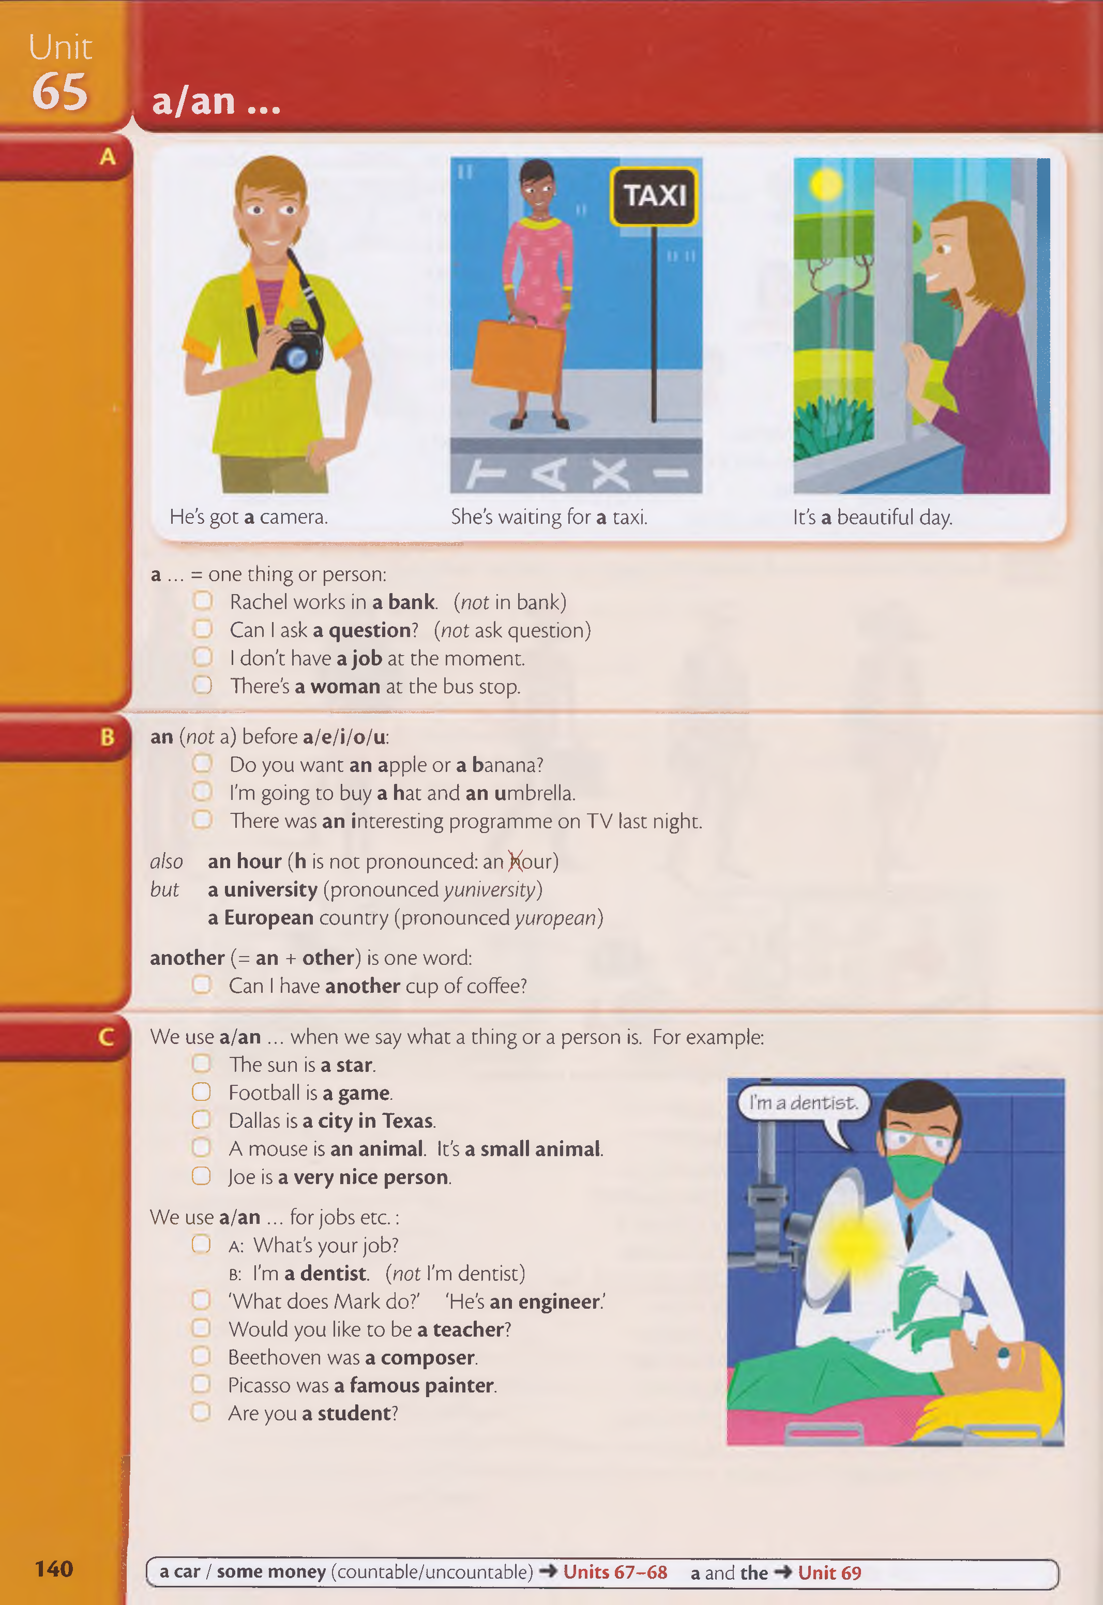

He's got **a** camera. She's waiting for **a** taxi. It's **a** beautiful day.

**a ...** = one thing or person:

Rachel works in **a bank.** (*not* in bank) Can I ask **a question?** (*not* ask question) I don't have **a job** at the moment.

) There's **a woman** at the bus stop.

**an (***not* a) before **a/e/i/o/u:**

Do you want **an apple** or **a** banana?

I'm going to buy **a** hat and **an** umbrella.

There was **an** interesting programme on TV last night.

*also* **an hour (h** is not pronounced: an Xour)

*but* **a university** (pronounced *yuniversity)*

**a European** country (pronounced *yuropean)*

**another** (= **an** + **other)** is one word:

Can I have **another** cup of coffee?

We use **a/an** ... when we say what a thing or a person is. For example: The sun is **a star.**

O Football is **a game.**

C Dallas is **a city in Texas.**

A mouse is **an animal.** It's **a small animal.**

O Joe is **a very nice person.**

We use **a/an** ... for jobs e tc.: ( J **a :** What's **your job?**

**b:** I'm **a dentist. (***not* I'm dentist)

'What does Mark do?' 'He's **an engineer.'**

Would you like to be **a teacher?**

Beethoven was **a composer.** Picasso was **a famous painter.** Are you **a student?**

**140** *c* **a car / some money** (countable/uncountable) **Units 67-68 a** and **the Unit 69**

# Exercises

an

a

a

an

**Write a or an.**

a

a

1. an old book
2. window
3. horse

a vegetable

a tool

a game

1. airport
2. new airport
3. organisation

. university

an

. hour

a

economic problem

**What are these things? Choose from the box.**

a musical instrument

a flower

a river

a fruit

a planet

K*U*j**I**y**I** f**u**j

**flower**

a mountain

**fruit game**

**mountain planet**

**river tool**

**musical instrument vegetable**

1. A duck is a bird.
2. A carrot is .................
3. Tennis is .....................
4. A hammer is ...........
5. Saturn is ...............
6. A banana is ........
7. The Amazon is .
8. A rose is ...............
9. 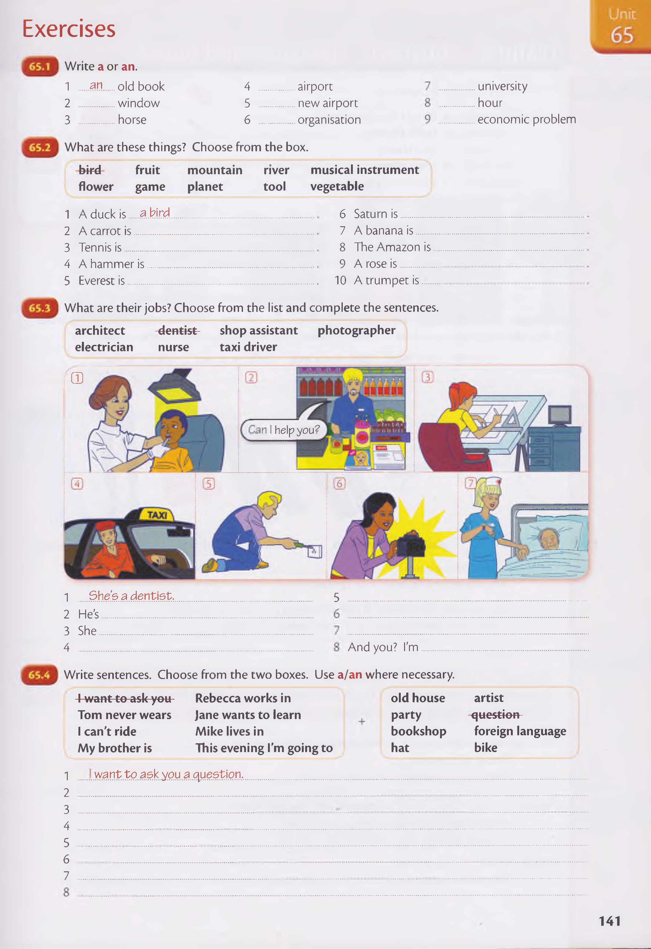Everest is ...................................................................................... 10A trumpet is .......

**What are their jobs? Choose from the list and complete the sentences,**

|  |  |  |  |
| --- | --- | --- | --- |
| **architect** | **-dentist-** | **shop assistant** | **photographer** |
| **electrician**  CD | **nurse** | **taxi driver** |  |

#### help you?

He´s an electrician

She´s a photographer

a shop assistant

She´s a nurse

is an architect

a student

He´s a taxi driver

1. She’s a dentist 5
2. He's.
3. She...

Tom never wears a hat

1. ........... And you? I'm .

I can´t ride a bike

**Write sentences. Choose from the two boxes. Use a/an where necessary.**

Mike lives in an old house

This evening I´m going to a party

Jane wants to learn a foreign language

Rebeca works in a bookshop

My brother is an artist

### Unit

**69 a/an** and **the**

**a/an the**

,

#### Can you open

**a** window?

There are *three* windows here,

**a** window - window 1 or 2 or 3

O I've got **a car.**

(there are many cars and I've got one)

O Can I ask **a question?** (there are many questions - can I ask one?)

O Is there **a hotel** near here? (there are many hotels - is there one near here?)

O Paris is **an interesting city,** (there are many interesting cities and Paris is one)

O Lisa is **a student.**

(there are many students and Lisa is one)

#### Can you op

**the** window?

There is only *one* window here -

**the** window.

O I'm going to clean **the car** tomorrow. (= my car)

Can you repeat **the question,** please? (= the question that you asked)

J We enjoyed our holiday. **The hotel**

was very nice. (= our hotei) Paris is **the capital of France.**

(there is only one capital of France) Lisa is **the youngest student** in her class, (there is only one youngest student in her class)

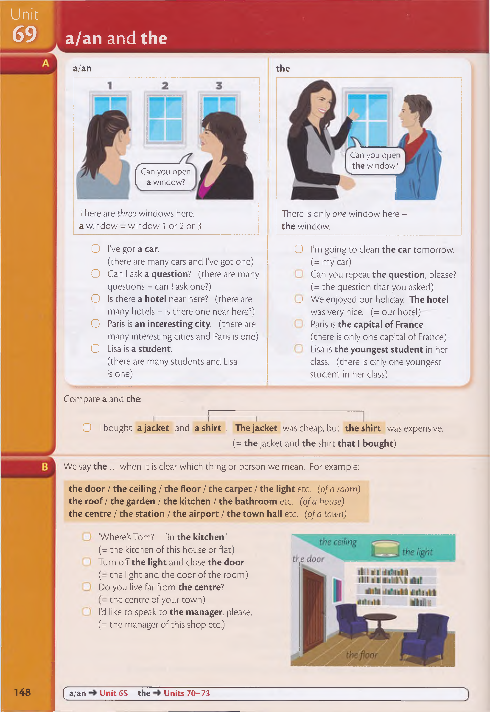

Compare **a** and **the:**

O I bought **a jacket** and **a shirt . The jacket** was cheap, but **the shirt** was expensive.

**(= the** jacket and **the** shirt **that I bought)**

We say **the** ... when it is clear which thing or person we mean. For example:

**the door** / **the ceiling** / **the floor** / **the carpet** / **the light** etc. *(of a room)*

**the roof** / **the garden** / **the kitchen** / **the bathroom** etc. *(of a house)*

**the centre** / **the station** / **the airport** / **the town hall** etc. *(of a town)*

'Where's Tom? 'In **the kitchen.'**

(= the kitchen of this house or flat) Turn off **the light** and close **the door.** *( -* the light and the door of the room) Do you live far from **the centre?**

the centre of your town)

I'd like to speak to **the manager,** please. (= the manager of this shop etc.)

**148 ( a/an Unit 65 the Units 70-73**

# Exercises

W rite a/an or the.

1. We enjoyed our trip hotel was very nice.
2. 'Can I ask a question?' 'Sure. What do you want to know?'

a

1. You look very tired.- You need holiday.

the

1. 'Where's Tom?' 'He's in garden.'

an

1. Eve is interesting person. You should meet her.

the

the

1. a : Excuse me, can you tell me how to get t o city centre?

a

a

b: Yes, go straight on and then take next turning left.

an

the

a

a

a

a

1. a : Shall we go out fo r meal this evening?

a

a

the

The

a

a

The

b: Yes, that's good idea.

1. It's nice morning. Let's go fo r walk.
2. Amanda is ..................student. When she finishes her studies, she wants to b e journalist. She lives with two friends in apartment near college where she is studying.................... apartment is small, but she likes it.
3. Peter and Mary have two children, boy an d girl. boy is seven years old, and

girl is three. Peter works in factory. Mary doesn't have job at the moment.

**Complete the sentences. Use a or the + these words:**

**airport cup dictionary door floor picture**

a cup

the airport

the dictionary

the floor

a

picture

send me a postcard

What is the name

Canada is a very

What is the largest

We live in an old house

No, I’ve got a headache

I don’t like the color of a carpet

**These sentences are not correct. Put in a/an or the where necessary.**

What is the name

1. Don't forget to tujm^offlight when you go out Turn off the.li^ht.

### Unit

## th e ...

We use **the** when it is clear which thing or person we mean:

**O** What is **the name** of this street? (there is only one name)

**O** W ho is **the best player** in your team? (there is only one best player)

**O** Can you tell me **the time,** please? (= the time *now)*

**O** My office is on **the first floor.** (= the first floor of the building)

Don't forget **the:**

O Do you live near **the city centre?** (*not* near city centre)

O Excuse me, where is **the nearest bank?** (*not* where is nearest...)

**the sa m e ...**

O We live in **the same street.** *(not* in same street)

**O** Are these two books different?' 'No, they're **the same.'** *(not* they're same)

We say:

**the sun / the moon / the world / the sky / the sea / the country**

O **The sky** is blue and **the sun** is shining.

O Do you live in a town or in **the country?**

**the police / the fire brigade / the army** (of a city, country etc) O My brother is a soldier. He's in **the army.**

O What do you think of **the police?** Do they do a good job?

**the top / the end / the middle / the left** etc.

O Write your name at **the top of** the page. O My house is at **the end of** the street.

**%**

O The table is in **the middle of** the room.

O Do you drive on **the right** or on **the left** in your country?

the left the right

the bottom

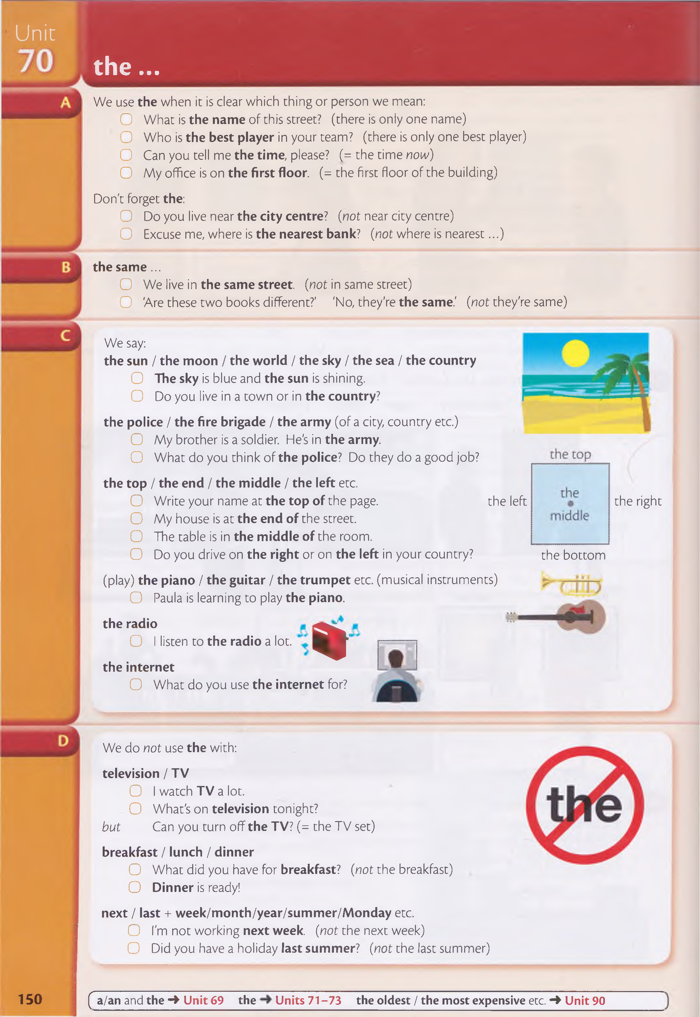(play) **the piano / the guitar / the trumpet** etc. (musical instruments)

**O** Paula is learning to play **the piano.**

**the radio**

O I listen to **the radio** a lot.

**the internet**

O What do you use **the internet** for?

We do *not* use **the** with:

**television / T V**

**O** I watch **TV** a lot.

O What's on **television** tonight?

*but* Can you turn off **the TV?** *(=* the TV set)

**breakfast / lunch / dinner**

**O** What did you have for **breakfast?** (*not* the breakfast)

**O Dinner** is ready!

**next / last + week/month/year/summer/Monday** etc. O I'm not working **next week,** *(not* the next week)

O Did you have a holiday **last summer?** *(not* the last summer)

**150 ( a/an** and **the ■» Unit 69 the Units 71-73 the oldest / the most expensive** etc. 4 **Unit 90**

# Exercises

**^ Put in the where necessary. Write 'OK' if the sentence is already correct.**

1. What is name of this street?.................................................................. ....The. name........................
2. What's on TV tonight? O K ........................................

the second

1. Our apartment is on second floor.........................................................................................................

the best

to the moon

1. Would you like to go to moon?......................................................... ....................................................

the city center

Ok

1. Which is best hotel in this town?...................................................... ....................................................

the next

at the

1. What time is lunch?................................................................................... ....................................................

Ok

the internet

Ok

the first

1. How far is it to city centre?

the right

1. We're going away at end of May........................................................ ....................................................

the nearest

1. What are you doing next weekend?................................................ ....................................................
2. I didn't like her first time I met her.................................................... ....................................................
3. I'm going out after dinner....................................................................... ....................................................
4. It's easy to get information from internet..................................... ....................................................

the same colour

the same age

the same time

1. My sister got married last month...................................................... ....................................................

the same problem

1. My dictionary is on top shelf on right............................................ ....................................................
2. We live in country about ten miles from nearest town...........................................................

**Complete the sentences. Use the same + these words:**

**age colour problem street time**

1. I live in North Street and you live in North Street. We live in Tha.sam e.straet.
2. I arrived at 8.30 and you arrived at 8.30. We arrived a t ...........................................................
3. James is 25 and Sue is 25. James and Sue are.................................................................................
4. My shirt is dark blue and so is my jacket. My shirt and jacket are...................................
5. I have no money and you have no money. We have..............................................................

the guitar

TV

**Look at the pictures and complete the sentences. Use the if necessary.**

finish

the sea

the breakfast

I® ®

I L isa B lack

the name

I ***Paul*** Roberts

The sky

C k rls Stone

*m*

Rebecca W atson mlm S a ra h Kelly

launch

the capital

the police

TV

Tom H o w a r d s

the middle